What is API?

* An API (or “Application Programming Interface”) is a software intermediary for an application or service that enables other applications or services to send them requests and receive responses to those requests.
* An API (or “Application Programming Interface”) is a software intermediary for an application or service that enables other applications or services to send them requests and receive responses to those requests.
* An API (or “Application Programming Interface”) is a software intermediary for an application or service that enables other applications or services to send them requests and receive responses to those requests.
* An API (or “Application Programming Interface”) is a software intermediary for an application or service that enables other applications or services to send them requests and receive responses to those requests.

It is a link between applications or services. It is a way of communication between application or services. They allow different systems to talk to each other.

Example:

A waiter in a restaurant is an api that takes order from customer (request) and pass it to chef and later chef sends required food to customer (respond). So it connects services or client side and server side

What is Digital Transformation?

Integration of digital technology into all areas of business, changing way of operation

**API is the key to Digital Transformation**

Example:

Payment as a service (make separate payment api)

AI as a service (AI api)

APIs used to access separate systems and provide necessary connectivity

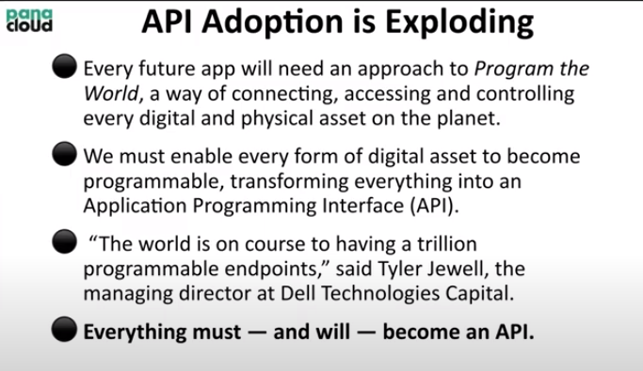

Every physical and digital asset will become API. Every single thing will become API, sofa ,car brakes everything

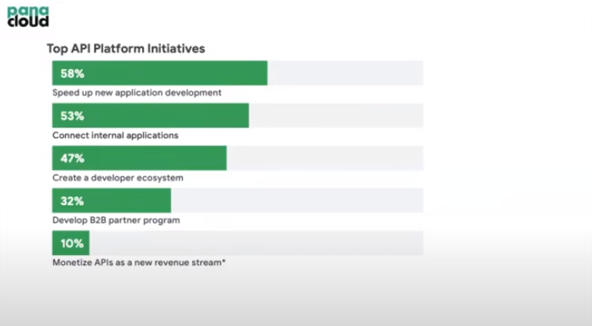

Monetizing apis are our aim

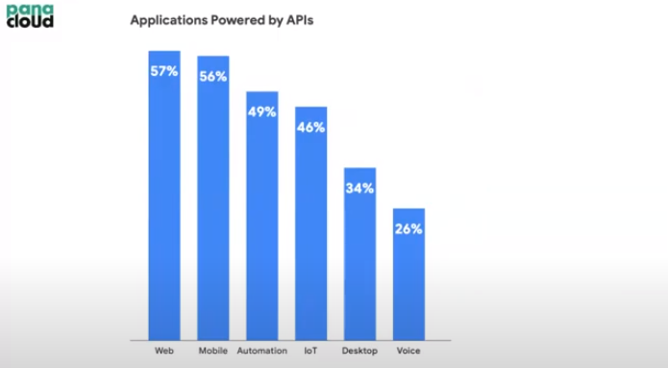

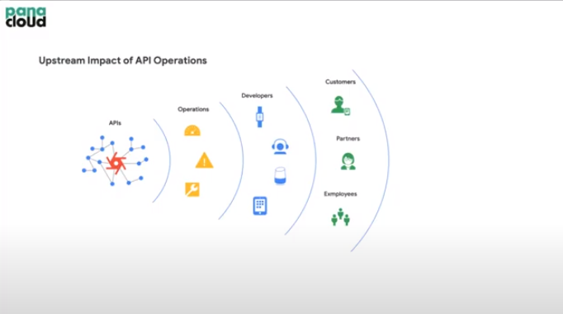

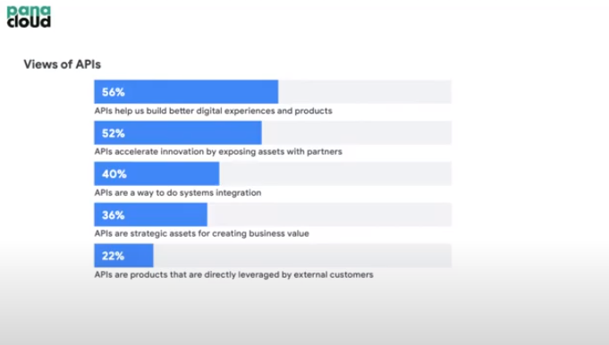

API as a Product:

API is now become a product. It can be sell. One problem associated with it is market to sell API. But API should be bit complex so that companies can buy from you instead of building by themselves which save their time

Example:

Stripe API for payment method

Google map API used by foodpanda, uber, careem and other companies

Interests in API:

Growth of cloud computing which has led to the need for API integration

What is the API Economy?

APIs has lead to SaaS world which results in API Economy. Developers creates API and SaaS can be build by combining different APIs and developers can earn money by monetizing those APIs

The exchange of these APIs and the systems to manage them is, in a nutshell, the API economy

In api economy, developers charge each others for the APIs build by them

The application developers who uses all these APIs bills the end-customers for the service. The exchange of values is what makes an API economy

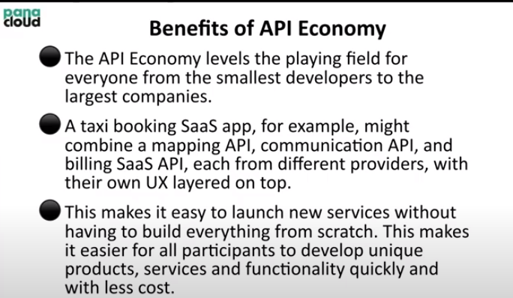

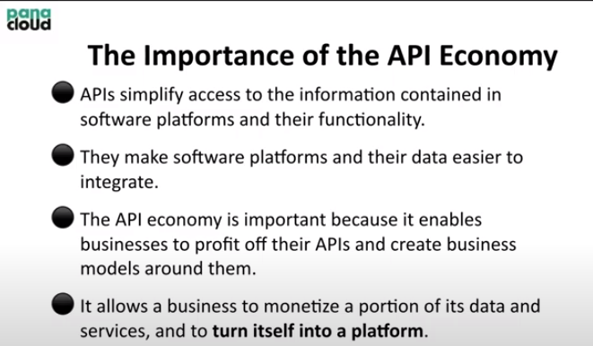

“The API economy is an enabler for turning a business or organization into a platform” – Gartner

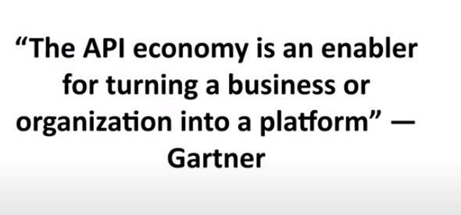

What is Platform?

A platform is a group of technologies, solutions, or offereings that form an iterative basis for developing, implementing or deploying other offerings

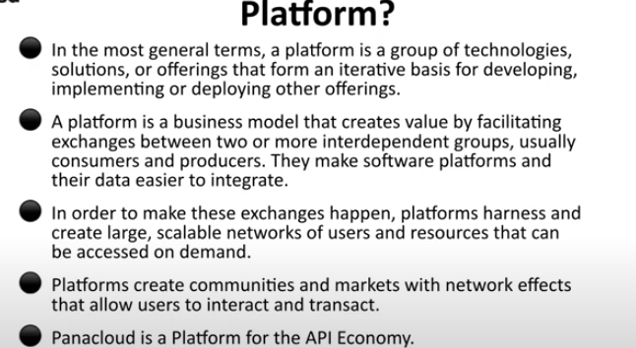

Anything that helps to develop their business in top of you is platform

API value Chain:

API-first company -> Developer -> Customer

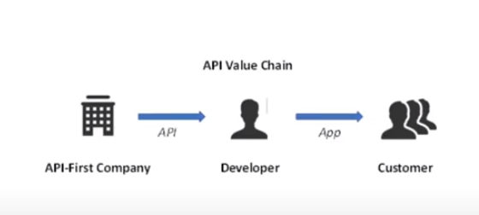

API-First Approach or API-First Company:

The idea is API-as-a-product. It allows oraganizations to build APIS that serve all applications and applications can be developed for all platforms and operating systems.

The same API can be used for mobile, web and chatbox

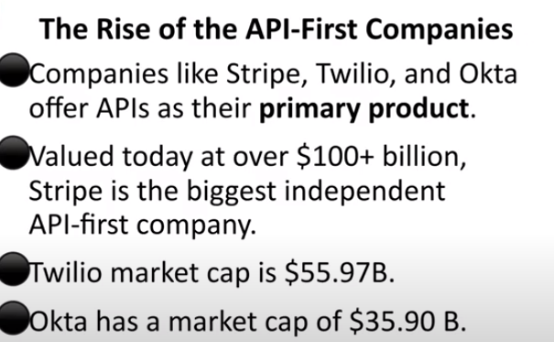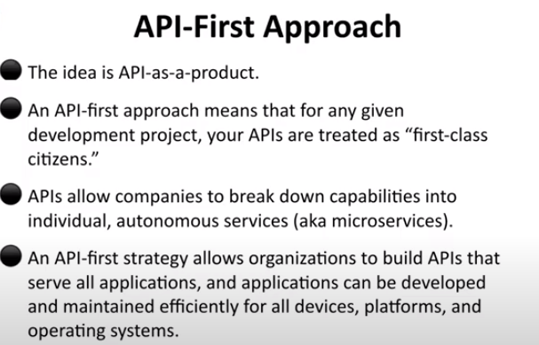

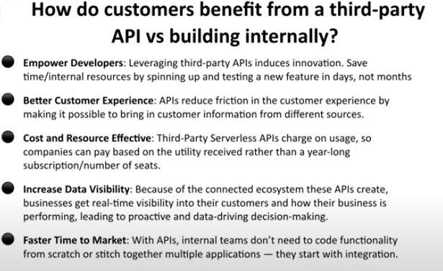

APIs will be serverless and multitenant.

What is multitenant?

When many people are using same resources. In this, one server serves many users

Earlier one for one person

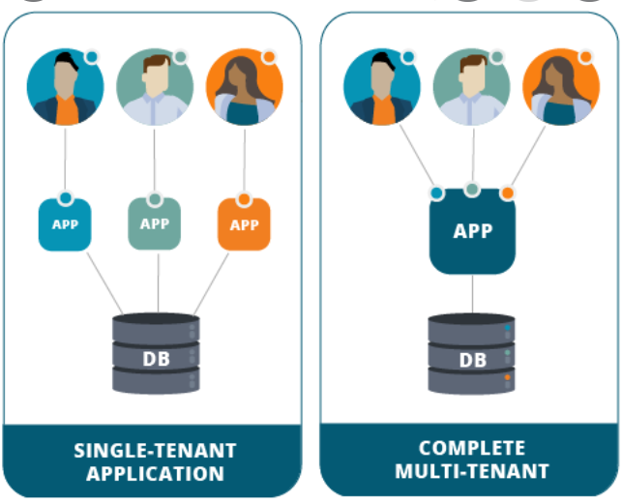

What is serverless (cloud 2.0)?

It does not means no server. It means server is on cloud and charger for only time user using it

Thus APIs should be or will be serverless and multitenant

Link Between APIs and AI:

Internal:

We know that digitization create lots of data and API leverage AI to make use of that data

External:

AI will manage APIs

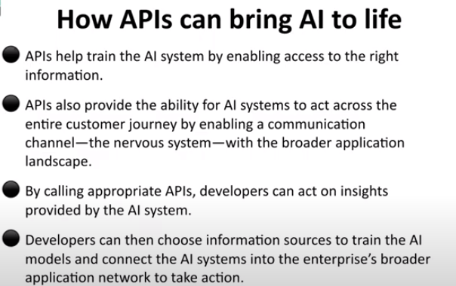

Link Between IoT and API:

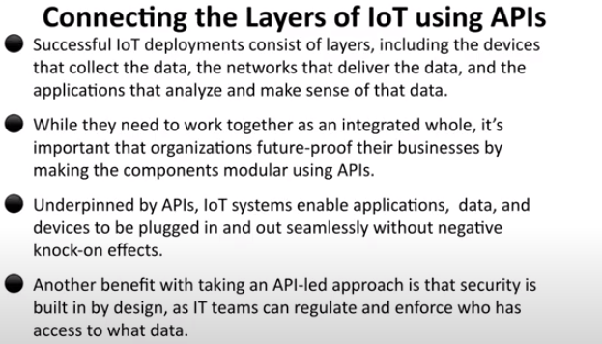

Link Between API and BlockChain:

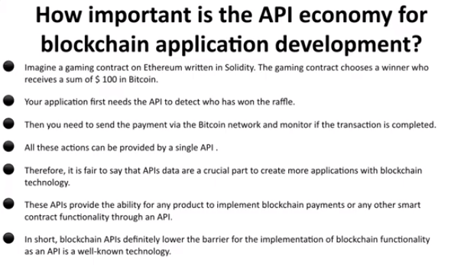

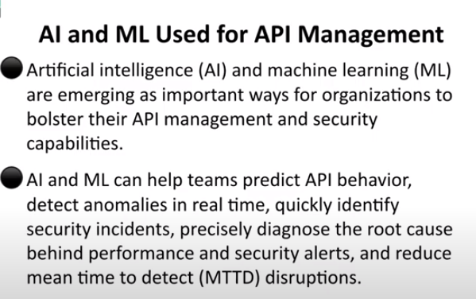

Standards for API Definition:

1. REST based OpenAPI

2. GraphQl

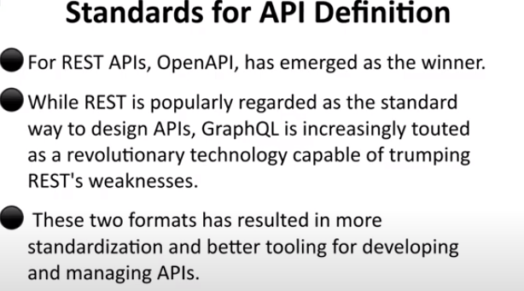

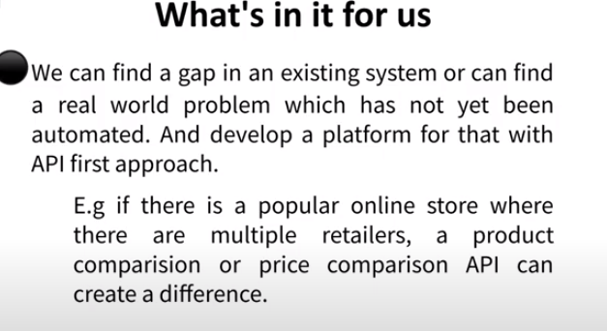

PROGRAMMABLE MONEY FOR API ECONOMY:

Problems to developers

1. Payment method.
2. Investment for startup
3. Payment Method:

Use of stable coin DAI is best for payment. By using cryptocurrency, we don’t need PAypal etc

What is Programmable Money?

It has to be in digital form, like tokens and can be tracked. BlockChain used in it

Sending money using API is not programmable money as bank can easily refuse it. In programmable money, we have full control

No bank or payment gateway will be involved or no transaction charges

Example:

DAI cryptocurrency

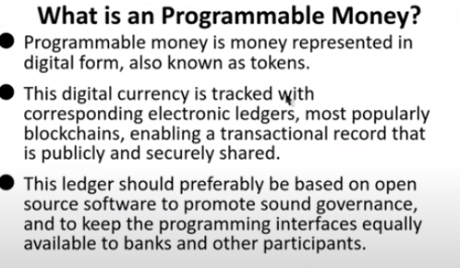

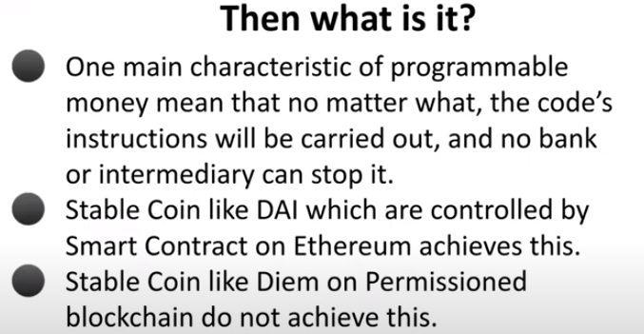

What is BlockChain:

Example:

If I put data in my harddrive consisting of list of people with their names and how much I already paid to them. As it is in my hard drive, it can easily be over ride or it is mutable. On the other hand If I used block chain for security, it can not be mutable (immutable). It is a pear to pear network, which is synchronized with other systems, so if someone wants to override it, everyone knows about it or in a nutshell, changing or overriding data is impossible

**Thus block Chain is a nodes (person1 has a node, person2 has a node…) communicating with each other and all nodes has a copy and synchronized. It addresses lack of trust of issues. Problem is of consensus which can be evacuate through different methods**

**Example:**

**History of world could not be changed so we keep it in blockchain**

What about data privacy in Block Chain?

We need to keep change the account number or public key number

What is Consensus?

Example:

Their can be transaction 1, 2 and 3

But there is a problem called consensus. Means how to add another transaction (how everyone will agree?

**Stable currency like DAI is controlled by smart contracts**

What is Smart contract?

It is a piece of code running on all nodes of network of block chain

1 dollar == 1 DAI

Smart contract make sure DAI price remains same to 1 dollar

What we do we tell smart contract to take my ether and give me DAI of it which will be stable for rest of life.

Let say I give 2 ethers to smart contracts worth of 5000 DAI, and asked smart contract to give me 5000 DAI. As soon as it gives mae 5000 DAI, it will not have any ethers or if ether price down or up it will not do arrangements for me. So instead of giving me all 5000 DAI, it will give me 3000 DAI and keep hold rest of 2000 DAI for some time, if ether price goes up or down, it will either compensate me or asked me to give some coins back as per the situation

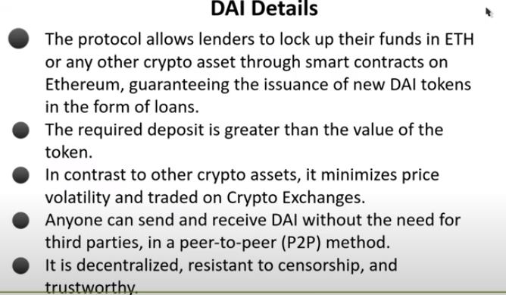

We are not going to work with smart contracts directly, we will use metamask wallet and its chrome extension

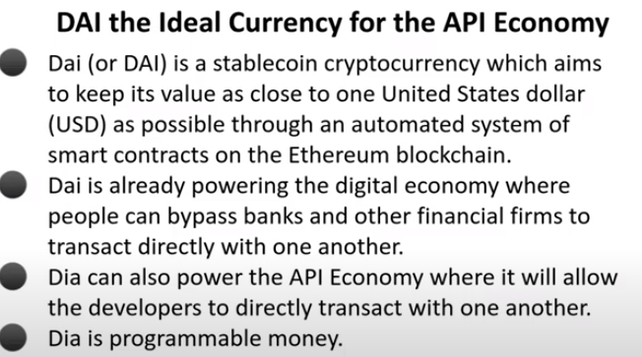

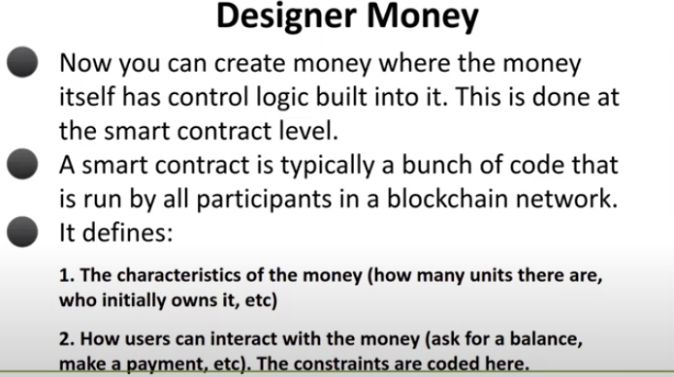

Ethereum is open source and can be used to create a coin

What is GAS:

Blockchain record transaction happen between two people and charge transaction fees called gas. Ether is necessary in your account and sent along with your transaction as a gas or transaction charges, if gas price less at that time, then it will return me my remaining ethers back

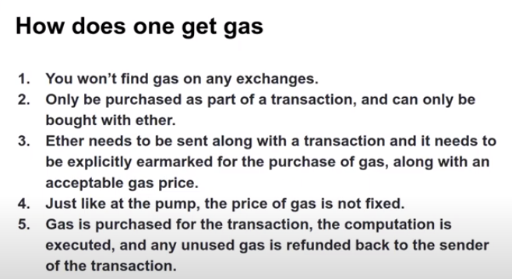

DECENTRALIZED APPLICATION (DApps)

It is a decentralized app comprises of smart contract and user interface

What is wallet?

It is a client side program running on your computer. It holds our private key and also public key, using public key it creates account number where people can sent money. Backup your private key is very critical.

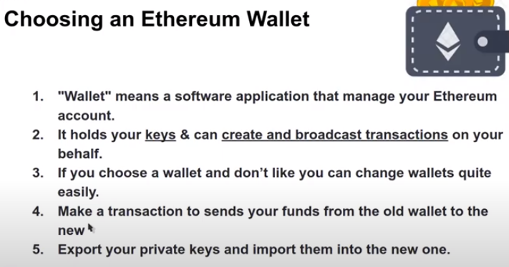

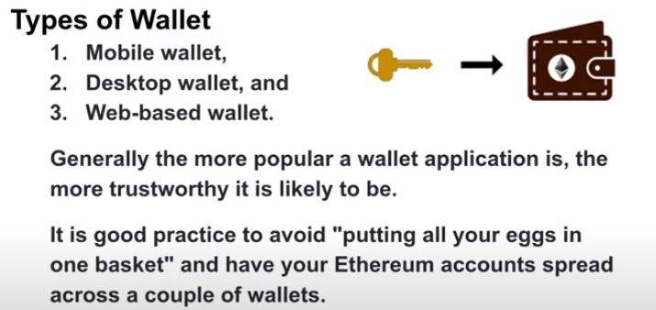

Meta mask is a web based wallet

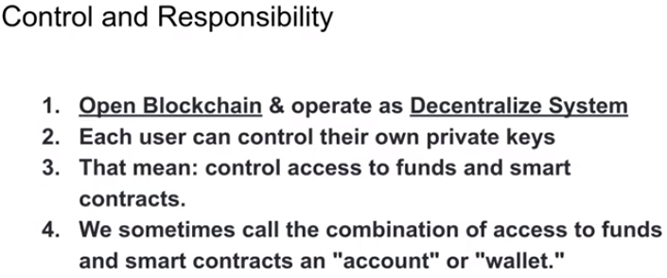

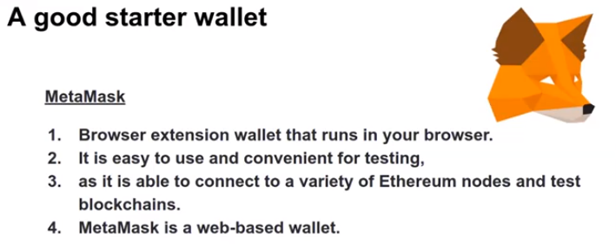

We use test ethereum network (ropsten test network)

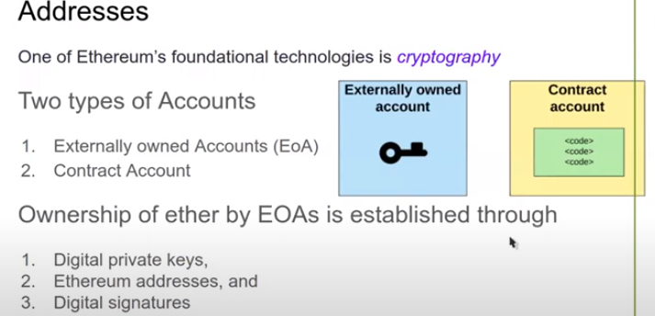

Externally owned account is the personal account, which holds by us using private key. On human being can do transactions (Externally owned accounts), contract account cannot initiate the transactions

Contract account, a smart contract. A piece of code on blockchain which has a specific address, only code control its, not by user. It is used for money conversion

In case of DAI, contract account is already created. If I am creating new coin like PAK coin, than I have to create new contract account and put code in it

ERC20 Tokens:

It is specific kind of smart contract with a specific functions like transfer or delete money etc. We can keep them in metamask. It is a fungible tokens (means all tokens are same) like Pakistani rupee or us dollar same. NFT is non-fungible token

What is a token?

Token is create on top of ethereum (on top of coin) using smart contract like ERC20 tokens. DAI is a ERC20 token which we can keep in our wallet

What is Smart Contract ?

It is just a fancy name for code that runs on blockchain, and interacts with thtat blockchain’s state

